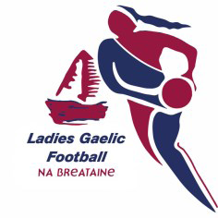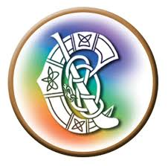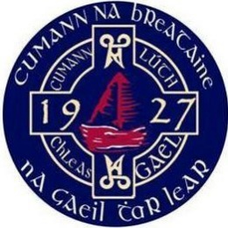

COVID-19 Frequently Asked Questions (FAQs) on the Safe Return to Gaelic Games for the Province of Britain

The Gaelic Games Council of Britain published a plan for a safe return to Gaelic games for the three organisations on 24 June 2020.

It is understood that there have been concerns across all bodies regarding the safe return to their sports, and some questions have been raised. We wanted to facilitate the safe return to sport and as such the Gaelic Games Council of Britain have developed this FAQ sheet which will be updated frequently and hopefully address those queries while supplementing the previously released plan for a safe return to Gaelic games.

Last updated 28 June 2020

FAQs

|  |  |
| --- | --- |
| **Q.1.** | **Which government guidance is referenced in the statement and plan? Is this the UK or Ireland?** |
| A. | *The government guidance to be followed should be that of the locality where the club/county is located. For example, a club in Scotland would follow the Scottish government guidance, a club in Lancashire would follow the English government guidance. It does not include the UK Government as this also includes NI (of which is governed in GAA terms by the Ulster Council). Page 14 of the Return to Play document outlines which government guidance should be referenced.* |
| **Q.2.** | **What does the term "Phase 3" refer to in the document?** |
| A. | *Phase 3 refers to “Phase 3 of the Return to Play document”. The phases of return to Gaelic Games are outlined in the document. These are separate from any other ‘phase’ terminology such as those issued by respective governments.* |
| **Q.3.** | **Are footballs classed as 'equipment' in terms of the ban on sharing equipment?** |
| A. | *Technically yes, they are classed as equipment but the advice from the COVID-19 Advisory Group (members outlined on Page 17) is that footballs are relatively low risk so as long as they are sanitised before and after use. It will rest with the individuals concerned if they want to use them. There is no directive to say yes or no to using them, it is opt in/opt out at your own personal decision. Also it is important to remember that individuals do not need to share balls in Phase 3 of the return, they can use them as part of their own personal training.*  *There have also been questions raised regarding helmets, hurleys and sliotar—these are also classed as equipment and should not be shared in Phase 3 of the plan.* |
| **Q.4.** | **When will clubs be provided with Covid-19 signage relevant to England?** |
| A. | *Clubs can create their own (within the guidelines issued) or download signage from the* [*GAA Covid-19 Education portal*](https://learning.gaa.ie/covid19resources)*. Additional guidance can be found here:* [*ReOpening Facilities*](https://learning.gaa.ie/sites/default/files/ReOpening%20Facilities.pdf) |
| **Q.5.** | **Will clubs be provided with the 'standardised bib' to clearly identify the Covid-19 supervisors?** |
| A. | *There is no ‘standardised bib’ per say, the document merely states that the COVID supervisor on call should be identifiable and the use of a bib was an example given. It is up to the local unit to put their own process for identifying the COVID supervisor in place and agree it with the COVID Supervisor at the level immediately above, so for club with their county and for county with their Provincial.* |
| **Q.6.** | **The document references the government social distance guidelines as 2 metres, which government does it reference?** |
| A. | *See previous answer to Q1. Each entity will have its own guidance and this is being updated all the time. Some countries have lifted the 2m rule, while others, like Scotland have maintained this rule. The club and county should refer to their local government guidance.* |
| **Q.7.** | **Will our players have access to the online Health Questionnaire?** |
| A. | *Yes, clubs in Britain will have access to the online Health Questionnaire and this is the only platform that should be used. There are also PDF versions that can be downloaded here:* [*Health Questionnaire (English)*](https://learning.gaa.ie/sites/default/files/Health%20Questionnaire.pdf)*. The GAA have also published a very* [*helpful video*](https://www.youtube.com/watch?v=O1iHY6K0qWw&feature=youtu.be) *to guide through the process and published a* [*User Guide*](https://learning.gaa.ie/sites/default/files/Gaelic%20Games_Health%20Questionnaire_User%20Guide_22.06.2020.pdf)*. We cannot provide a Word version as they can be altered. For questions relating to the online HQ- please email* [*gmssupport@gaa.ie*](mailto:gmssupport@gaa.ie)*.* |
| **Q.8.** | **What are the parameters for training beginning the 29th June?** |
| A. | *In England, groups of 6 are now permitted to train. It is the responsibility of the club committee to interpret how these guidelines are approached and followed. Sport England has various resources that can be downloaded for clubs to help with this process. They can be found here:* [*SportEngland*](https://www.sportengland.org/how-we-can-help/coronavirus/return-play) *guidance.*  *The GAA Return to Play roadmap lays out the minimum expectations for a safe return including that only members of the same household travel together to the venue. This will remain in place until Phase 4 of the return to play roadmap.*  *In Wales, no more than two households. See* [*Welsh Sport Association*](https://wsa.wales/our-services/sports-advocacy-and-policy/covid-19-support/) *guidance for further information.*  *In Scotland, training is not permitted at this time. July 13th is the date given for a return to youth training. Adult training date for return is not yet given. See* [*SportScotland*](https://sportscotland.org.uk/covid-19/) *guidance for further information.* |
| **Q.9.** | **What do we do if someone tests positive after attending training?** |
| A | *With the registration system in place (The Covid Supervisor for each team should have a register of who attended training with the individual), those individuals should be alerted to the positive test and to monitor their health based on the local government guidance. Links to this guidance can be found in Page 4 of the Return to Play document.*  *If someone should feel unwell during a training session, they should leave immediately and follow their respective local government advice (i.e. phone NHS 24 or 111).* |