Step 1 log in to return to play using web link. <https://auth.gaaservers.net/auth/realms/gaa/protocol/openid-connect/auth?client_id=gaa-direct&redirect_uri=https%3A%2F%2Freturntoplay.gaa.ie%2F&state=9dff50e7-bfb6-47e8-982d-1ec26bd137fc&response_mode=fragment&response_type=code&scope=openid&nonce=5d52dc24-0de4-445c-b217-3dff473fb3d7> .Either on your phone, tablet or laptop.

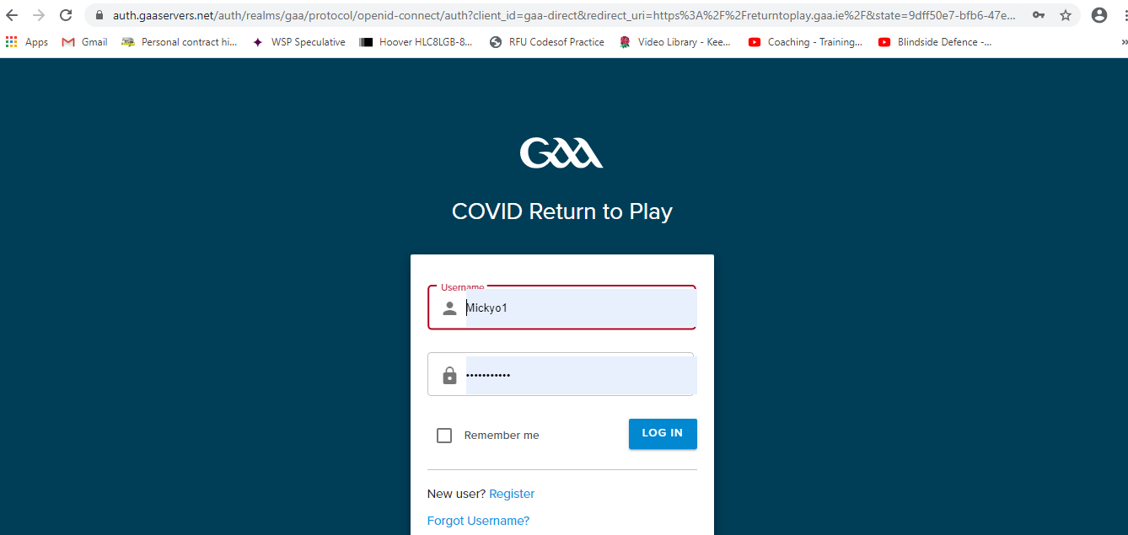

Step 2 If Anthony is at Training he can actually enter who attended and who was absent by just clicking away. Example below. Takes seconds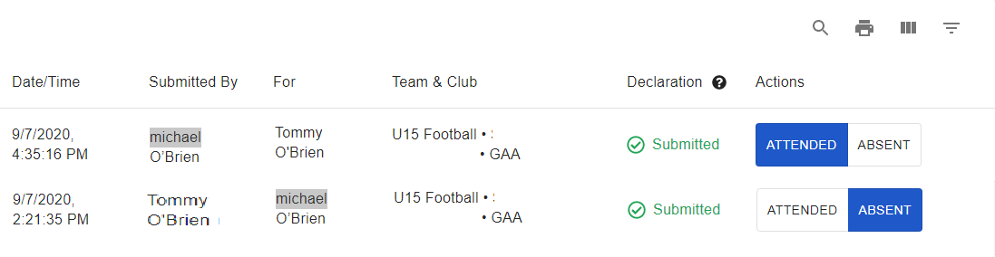

Step 3. Anthony then tells Viv who can then login and pull a report off by clicking the print button icon and if it’s like my printer you should be able to download it as a PDF. That can then go into the SharePoint

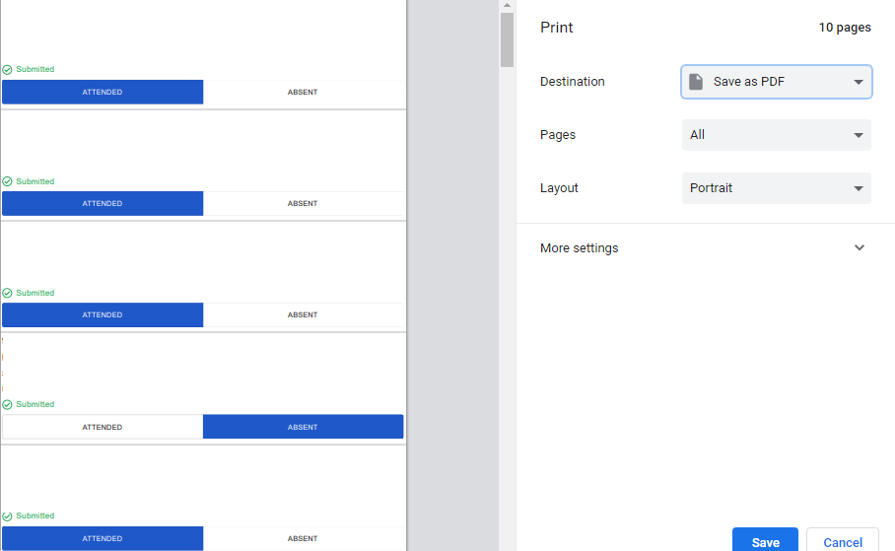

Remember you have these icons. Search, print, grid display and filters 